**PROJECT REPORT**

**About the Dataset**:

* The Dataset chosen by us is ‘Worldwide Suicide Rate.’
* Link: https://www.kaggle.com/russellyates88/suicide-rates-overview-1985-to-2016
* Columns:

1. Country
2. Year
3. Sex
4. Age
5. Suicide number
6. Population
7. Suicide per 100k population
8. GDP for year ($)
9. GDP per capita ($)
10. Generation

* No. of record: 27821

**Visualization:**

We used tableau for Visualization of the data. The visualizations were done based on different parameters which includes:

* Geo-segmentation based on the suicide rate by country.
* Suicide Rate per 100k of population.
* Distinct Count of Countries.
* Correlation of GDP per capita ($) to suicide rates.
* Suicide rate in relation to age and years.
* Horizontal Bar chart for Generation vs Suicide Rates
* Suicide rate based on Gender

**Method Used:**

* **Data collection –** The data was obtained from Kaggle for Worldwide Suicide Rate
* **Data cleaning –** The obtained data was cleaned by removing the null values and incomplete records
* **Tableau visualization –** Visualizations were created after analysis of the data. Filters, buttons, drill downs, map, storytelling and such features of tableau were used.

**Insights:**

1. Is GDP correlated with suicide rates?

One of the common reasons for suicide will be poverty. For analyzing the data for this view, we had plotted the GDP of the countries with the suicide rates. The graph plot shows a correlation between them, as the line graph initially rises along with the rise in GDP in the early 1980s to 1990s and then drops down by the year 2016 despite a very high GDP. Thus, we can conclude that the suicidal tendencies of the population decrease with an increase in GDP.

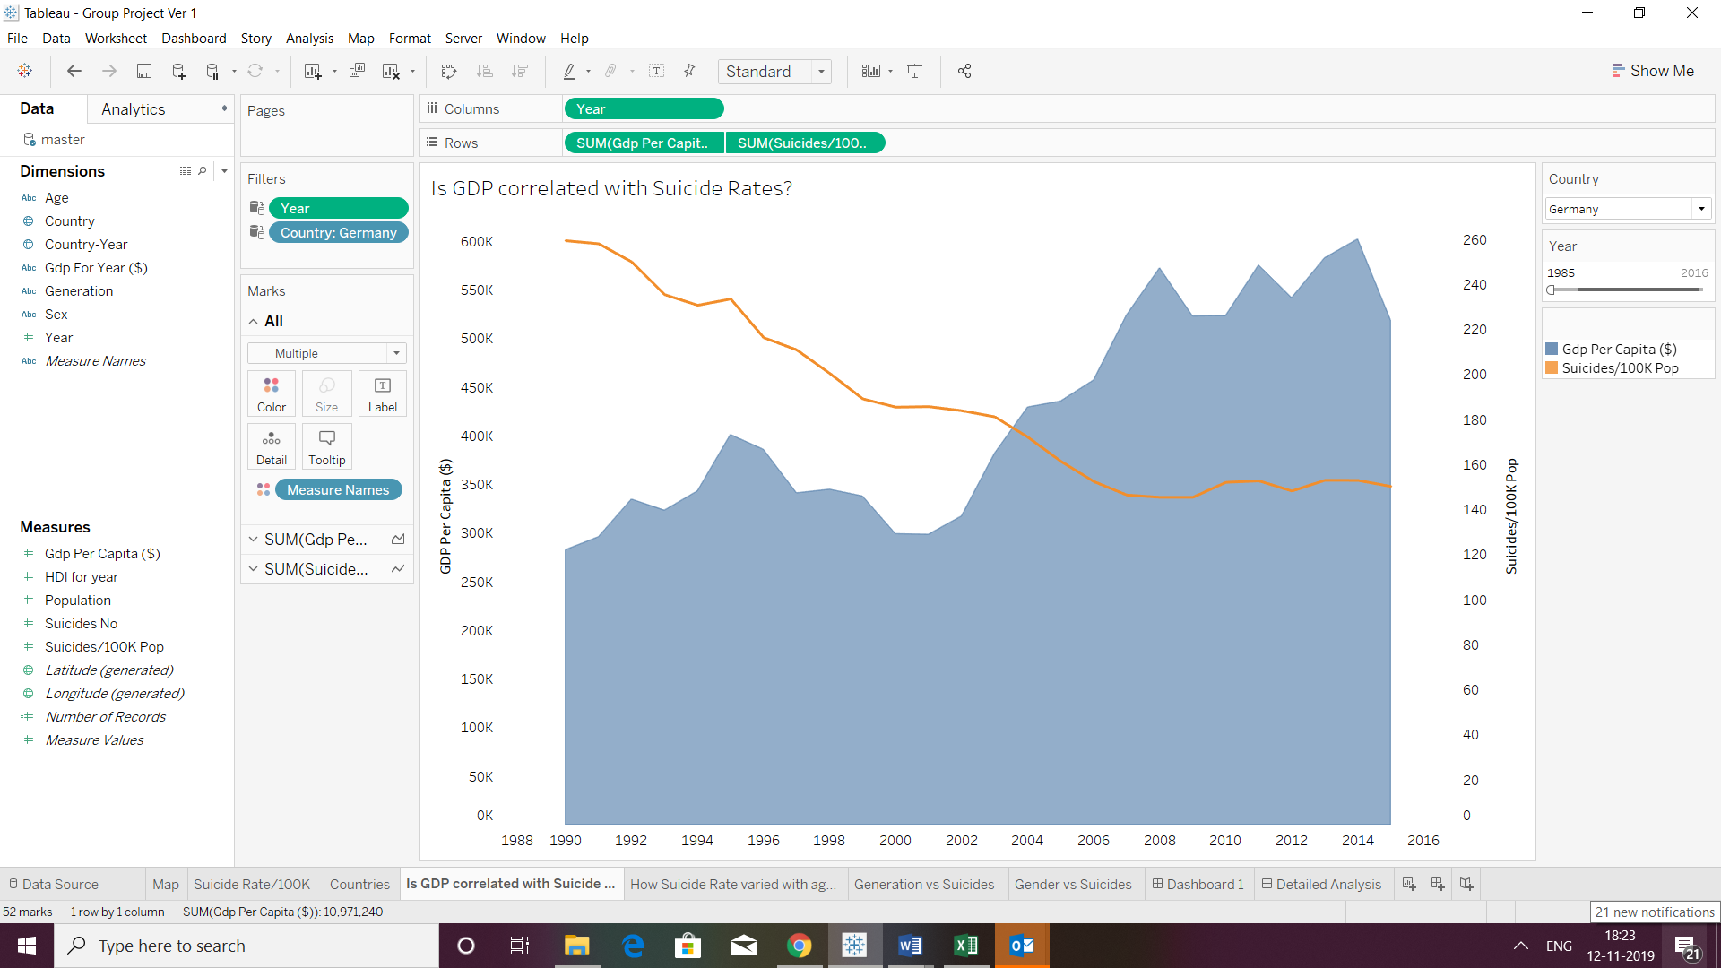

1. How suicide rate varies with age and years?

We had analyzed the suicide rates among the various age brackets. A line chart was generated for each of the age bracket with the suicide rates. The plot shows that the rates of suicides are almost even in 5-14 age group with fluctuations in the remaining categories. 75+ age bracket has the highest rising suicide intentions as depicted in the graph with fluctuations.

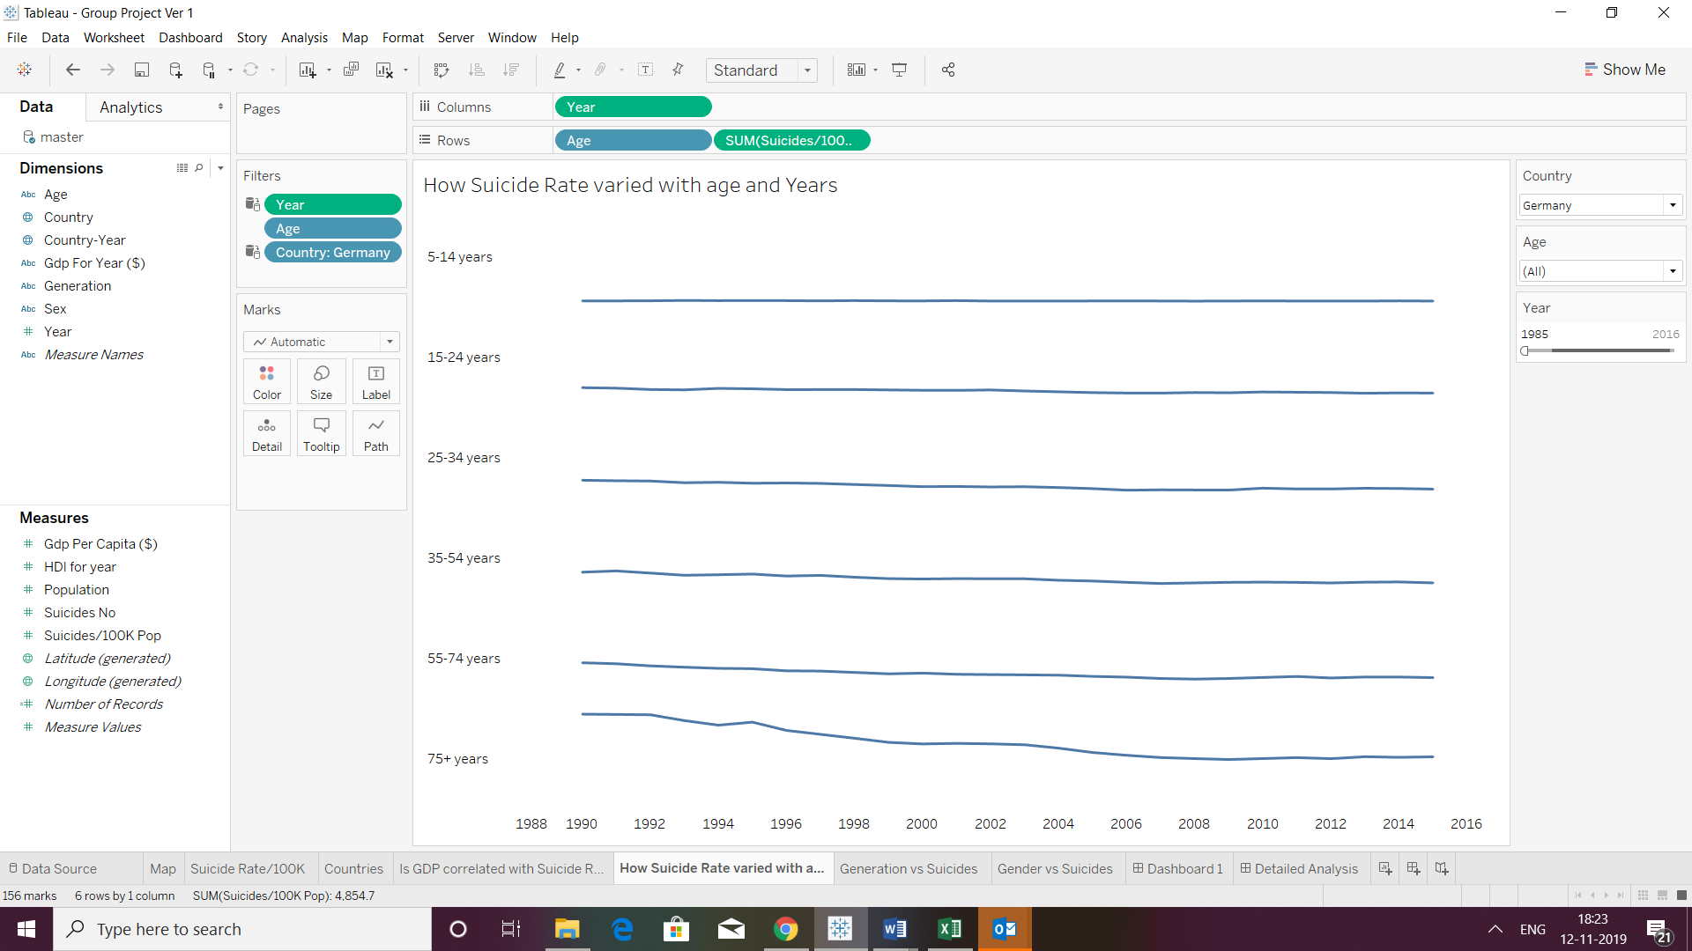

1. Gender vs suicides

We have taken the number of suicides occurring across the genders and placed year and country as filters. Upon plotting horizontal bar graph, we find that the suicide rates are high among the male gender than the female gender across countries. This could be because men generally avoid reaching out to others for help while women resort to friends to talk out their problems.

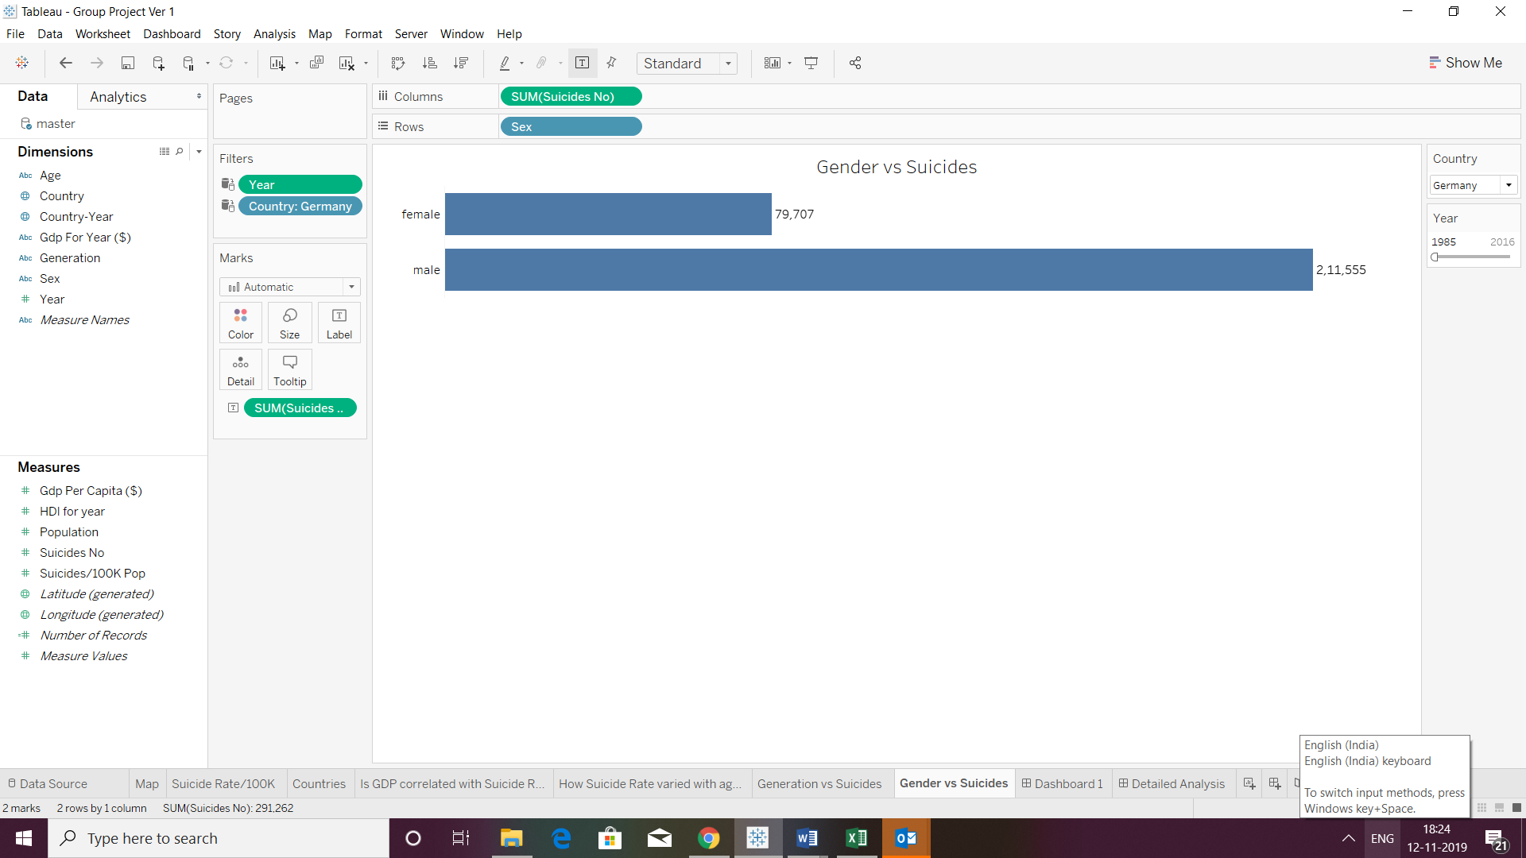

1. Generation Vs suicides

We had considered the suicide rates among various generations with filters as year and country. We find that boomers have the highest suicide rates between 1985 to 2005 and this could be because boomers were the generation which had the highest income and affluence among all. Following 2005 to 2016, we see generation X has the highest suicidal intentions which could be tied with the fact that they had reduced parental supervision and shifting societal values.

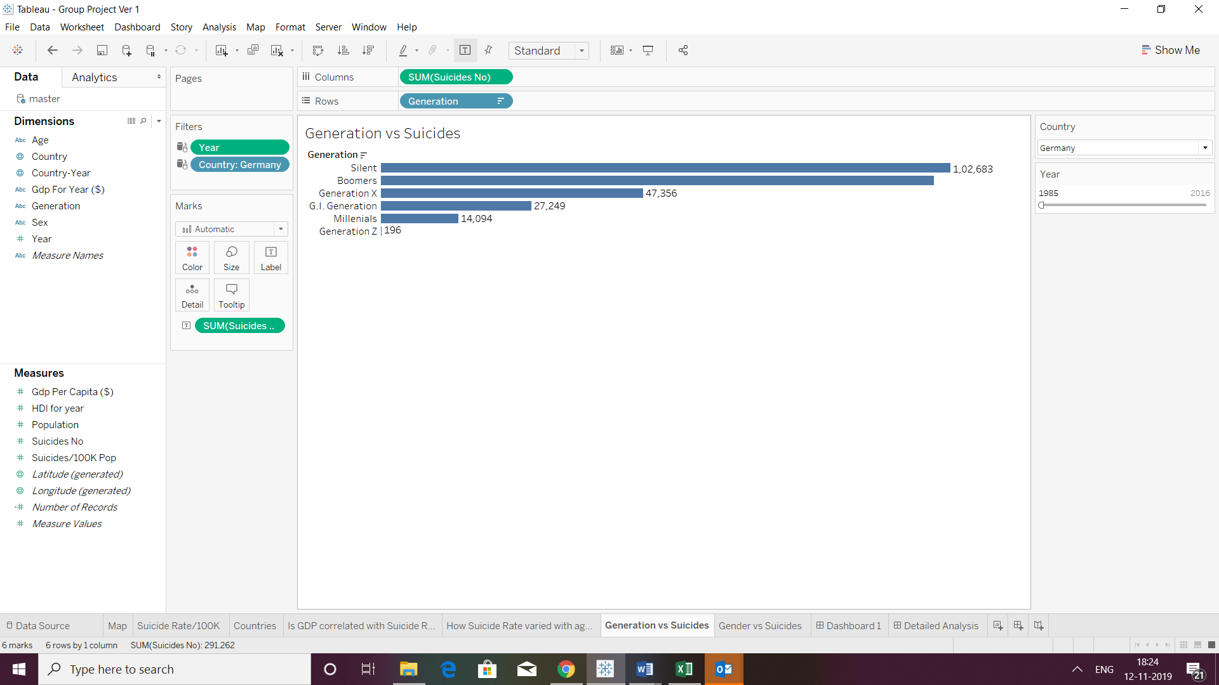

**Conclusion:**